Vaccination Management System (Salesforce CRM Project)

Project Overview
The Vaccination Management System is a Salesforce-based CRM application designed to manage vaccination drives efficiently. The system helps health authorities track beneficiaries, vaccine details, dose status, and overall vaccination progress. It provides centralized data management, automation, reporting, and dashboards to support informed decision-making and improve operational efficiency during vaccination campaigns.
Key features include beneficiary management, dose tracking (Dose 1 and Dose 2), validation of vaccination status, automated processes, and analytical dashboards for monitoring vaccination progress.

Objectives
The primary objective of this project is to build a scalable and user-friendly Salesforce CRM application to manage vaccination data effectively. The system aims to: - Maintain accurate records of beneficiaries and their vaccination status. - Track completion and pending vaccination doses. - Reduce manual errors through validations and automation. - Provide real-time insights using reports and dashboards. - Improve operational efficiency and data visibility for healthcare administrators.
These objectives directly support better public health management and data-driven decision-making.

Phase 1: Problem Understanding & Industry Analysis

Requirement Gathering
Requirements were gathered by analyzing the vaccination process, including beneficiary registration, dose administration, and reporting needs.

Stakeholder Analysis
Key stakeholders include health administrators, vaccination center staff, and reporting authorities.

Business Process Mapping
The vaccination workflow was mapped from beneficiary registration to dose completion and reporting.

Industry-Specific Use Case Analysis
The healthcare vaccination domain requires accurate tracking of doses, centers, and beneficiaries with high data integrity.

AppExchange Exploration
Relevant AppExchange solutions were reviewed to understand best practices in healthcare CRM implementations.

Phase 2: Org Setup & Configuration

Salesforce Edition
Salesforce Developer Edition was used for building and testing the application.

Company Profile Setup
The org was configured to represent a healthcare organization managing vaccination drives.

Business Hours & Holidays
Business hours and holidays were configured to reflect vaccination center operations.

Fiscal Year Settings
Standard fiscal year settings were used.

User Setup & Licenses
Users were created with appropriate profiles to simulate admin and staff access.

Login Access Policies
Basic login and password policies were configured for security.

Dev Org Setup & Sandbox Usage
Development was carried out in a Developer Org. Sandbox concepts were studied for deployment readiness.

Deployment Basics
Change Sets were explored for metadata migration.

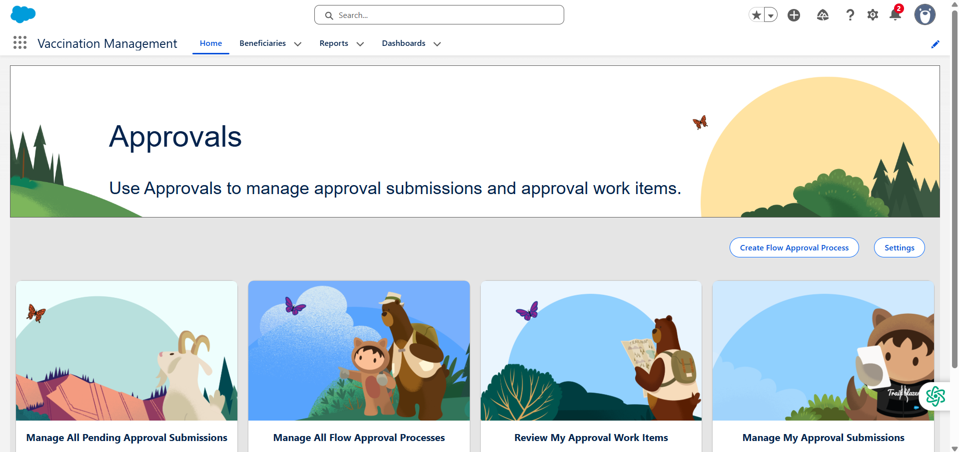
Figure 1: Salesforce Vaccination Management App Home Page

Phase 3: Data Modeling & Relationships

Custom Object: Beneficiary
Stores details such as Name, Age, Vaccine Type, Dose 1 Status, Dose 2 Status, and Vaccination Center.

Fields
Custom fields were created to capture vaccination-related data.

Record Types
Record types were analyzed; a single record type was used for simplicity.

Page Layouts & Compact Layouts
Page layouts were customized to display relevant beneficiary information clearly.

Relationships
Lookup relationships were used where applicable to link related data.

Schema Builder
Schema Builder was used to visualize object relationships.
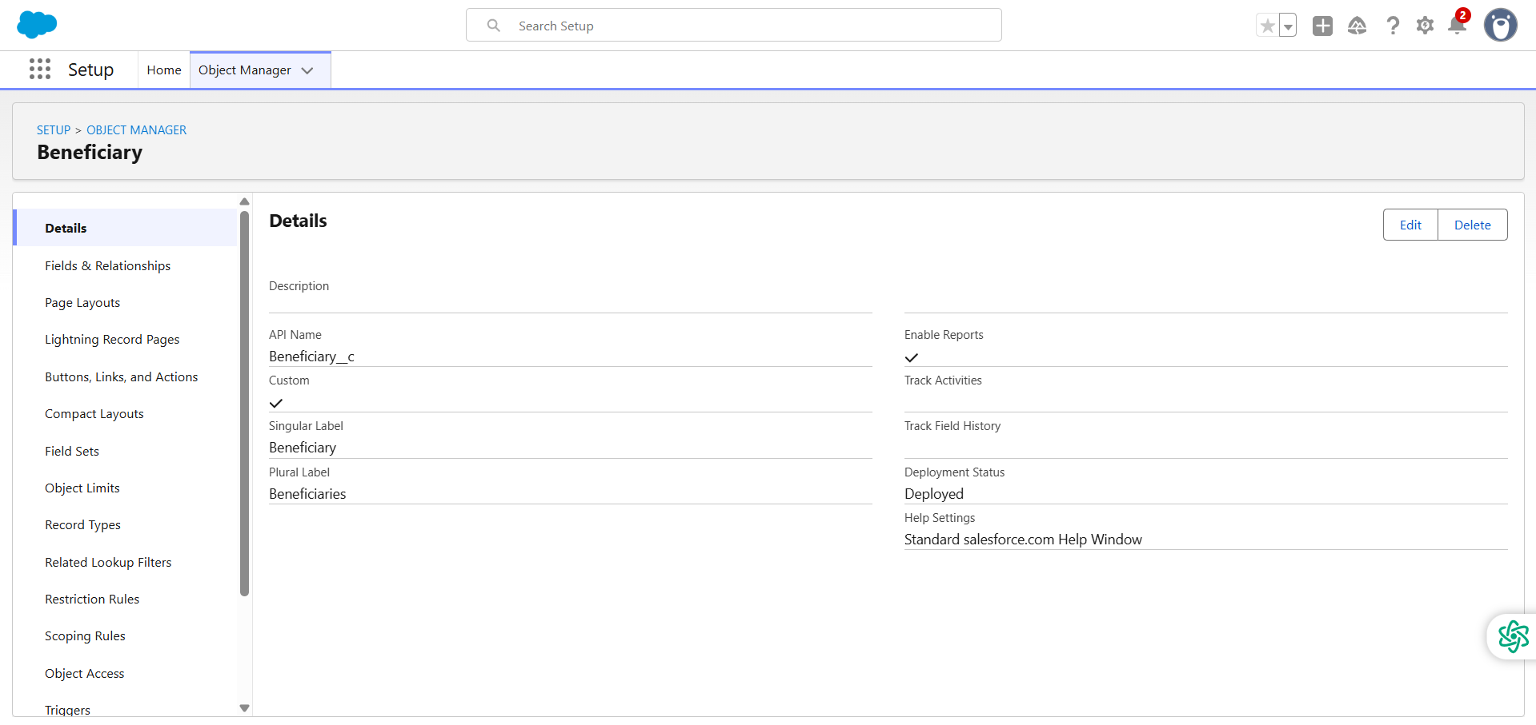
Figure 2: Beneficiary Custom Object Creation
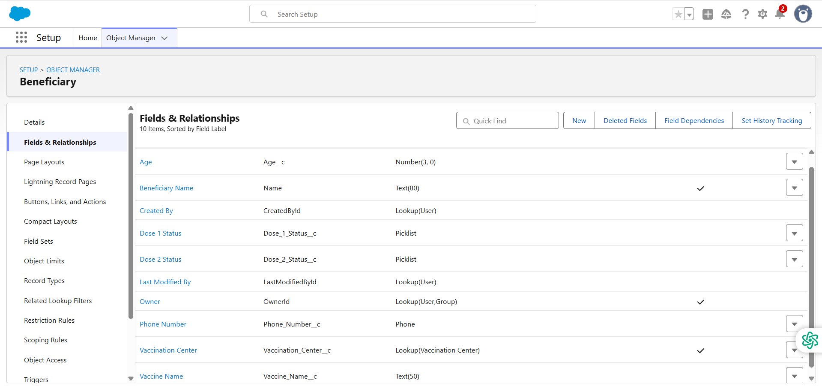
Figure 3: Custom Fields in Beneficiary Object

Phase 4: Process Automation (Admin)

Validation Rules
Validation rules ensure data consistency, such as preventing Dose 2 from being marked completed before Dose 1.

Workflow / Process Builder
Basic automation concepts were studied.

Flow Builder

Flow Builder concepts were studied for future automation.

Email Alerts & Field Updates
Explored conceptually for future enhancement.
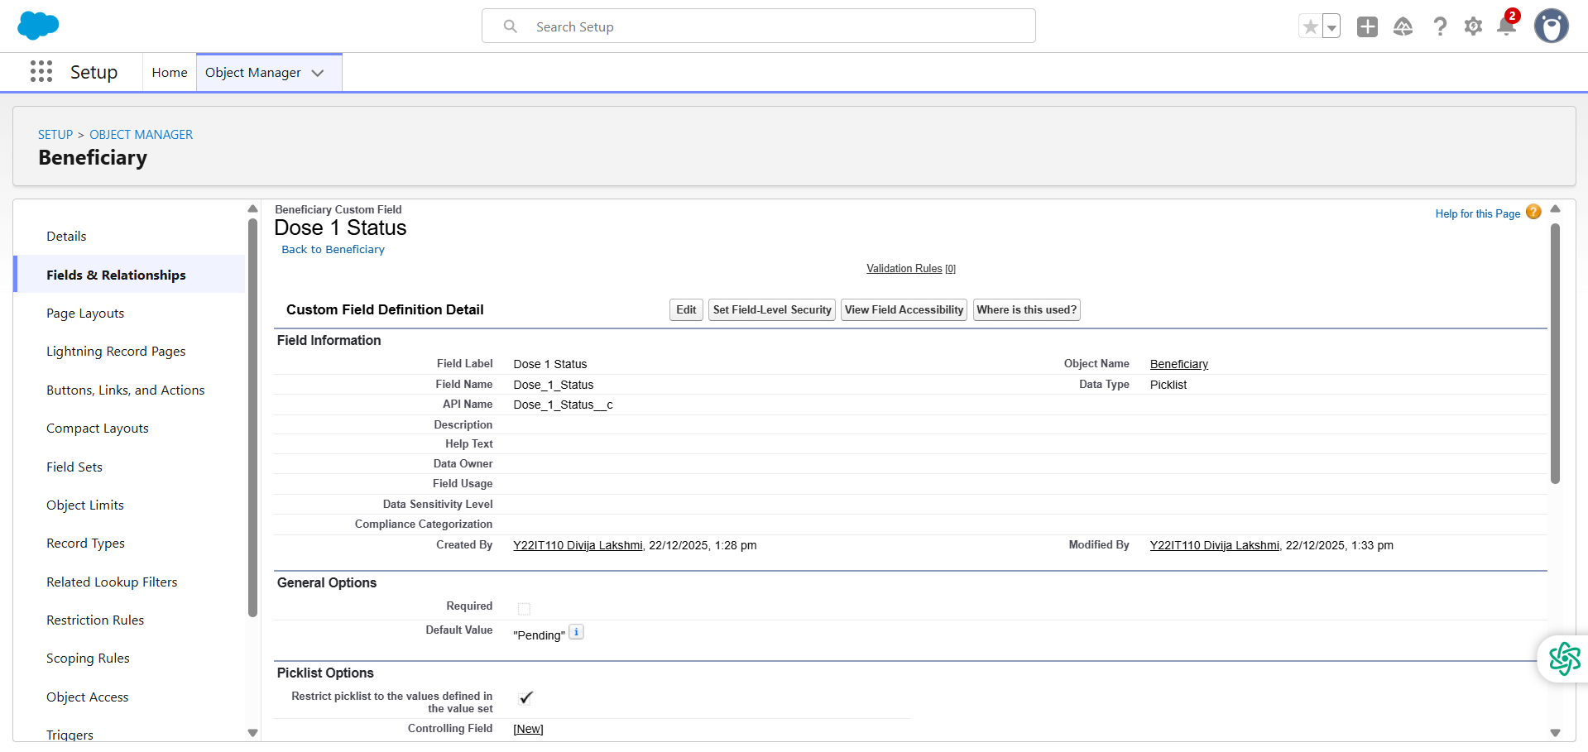
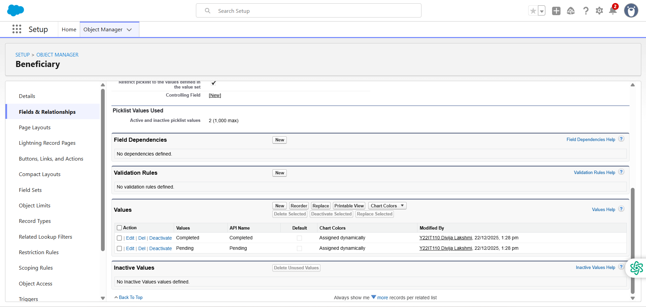
Figure 4: Dose Status Picklist Configuration
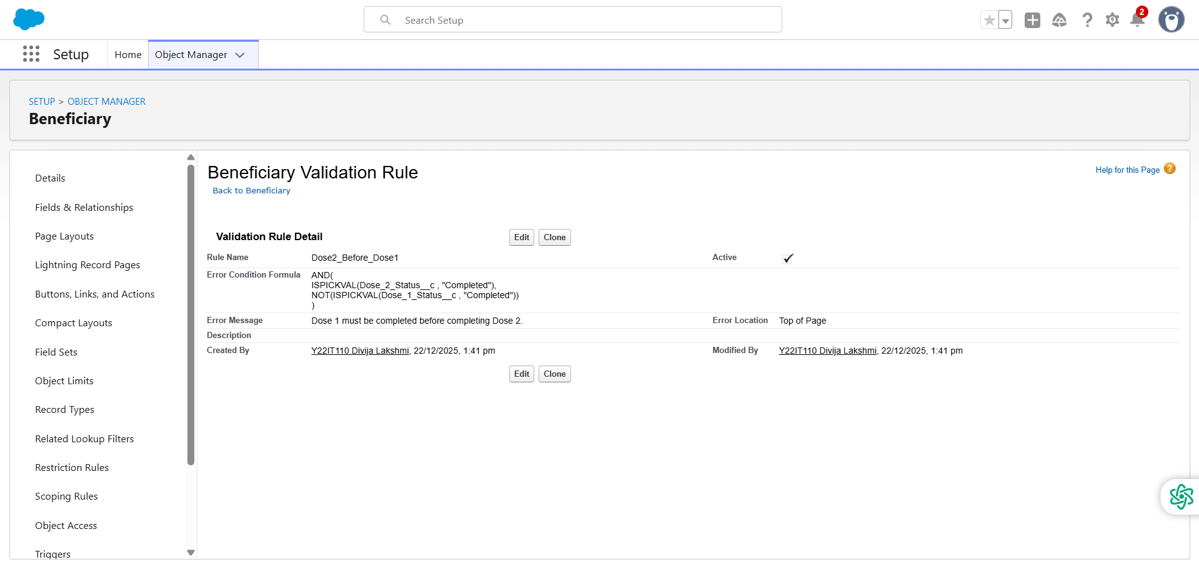
Figure 5: Validation Rule Logic Preventing Incorrect Dose Completion

Phase 5: Apex Programming (Developer)
Basic Apex concepts were studied. Advanced Apex (Triggers, Batch, Queueable) were reviewed conceptually for future scope. No complex Apex logic was implemented in this phase.

Phase 6: User Interface Development

Lightning App Builder
A custom app named Vaccination Management was created.

Record Pages
Lightning Record Pages were customized for the Beneficiary object.

Tabs
Custom tabs were created for easy navigation.

Home Page Layouts
A dashboard-driven home page was used to show vaccination statistics.

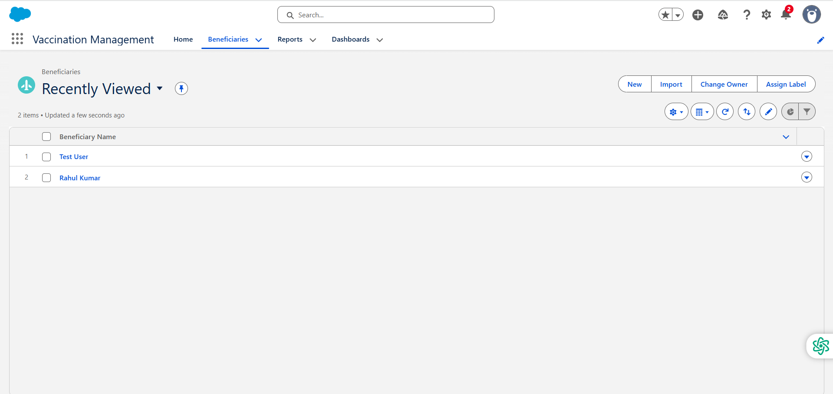
Figure 6: Beneficiaries List View

Phase 7: Integration & External Access
Integration concepts such as REST APIs, Named Credentials, and External Services were studied. No external integration was implemented in this version.

Phase 8: Data Management & Deployment

Data Import Wizard
Used to insert sample beneficiary records.

Duplicate Rules
Duplicate management concepts were reviewed.

Change Sets
Studied for metadata deployment.

Phase 9: Reporting, Dashboards & Security Review

Reports
- Total Beneficiaries Report (Summary Report with grouping)
- Pending Dose 2 Report (Summary Report with grouping)

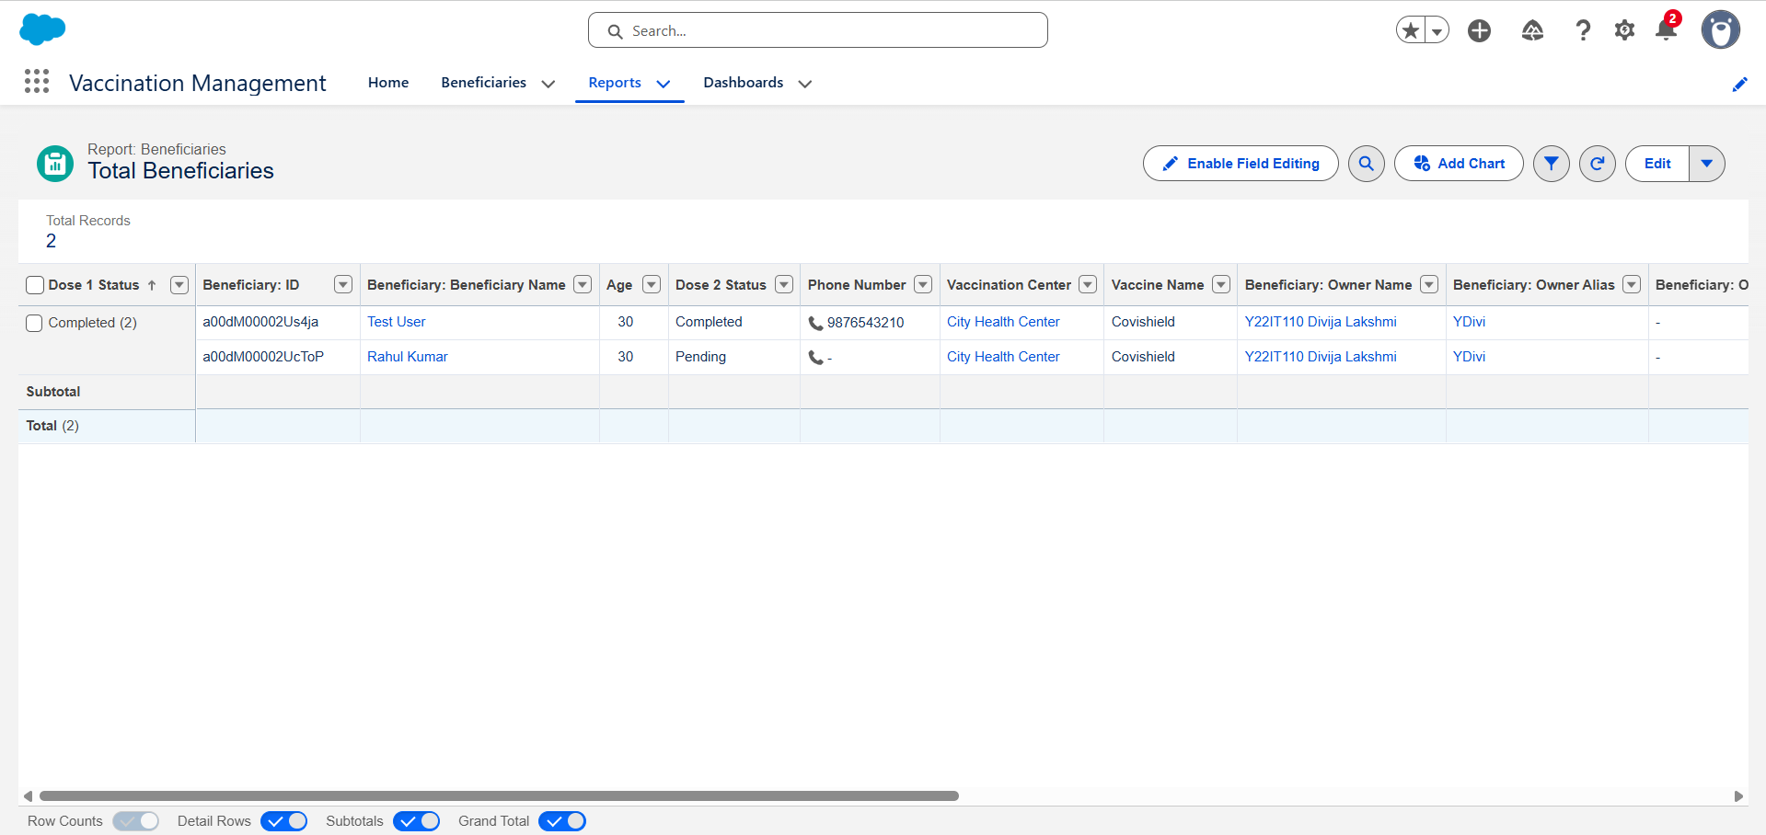

Figure 7: Total Beneficiaries Report
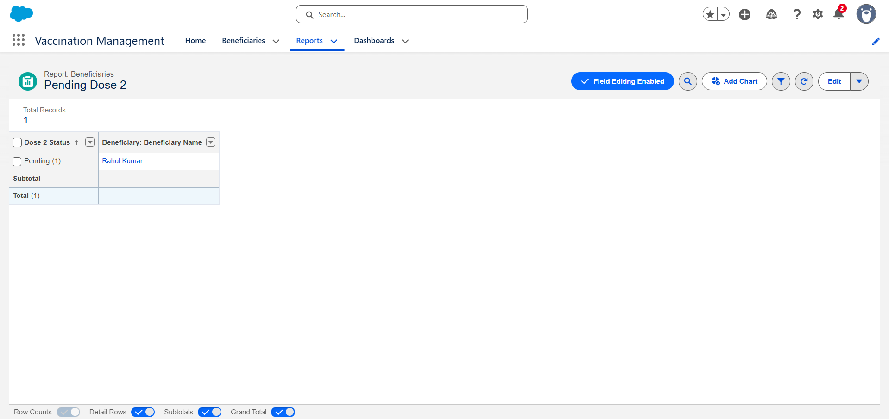

Figure 8: Pending Dose 2 Report

Dashboards
A dashboard named Vaccination Drive Dashboard was created with metric widgets: - Total Beneficiaries - Pending Dose 2
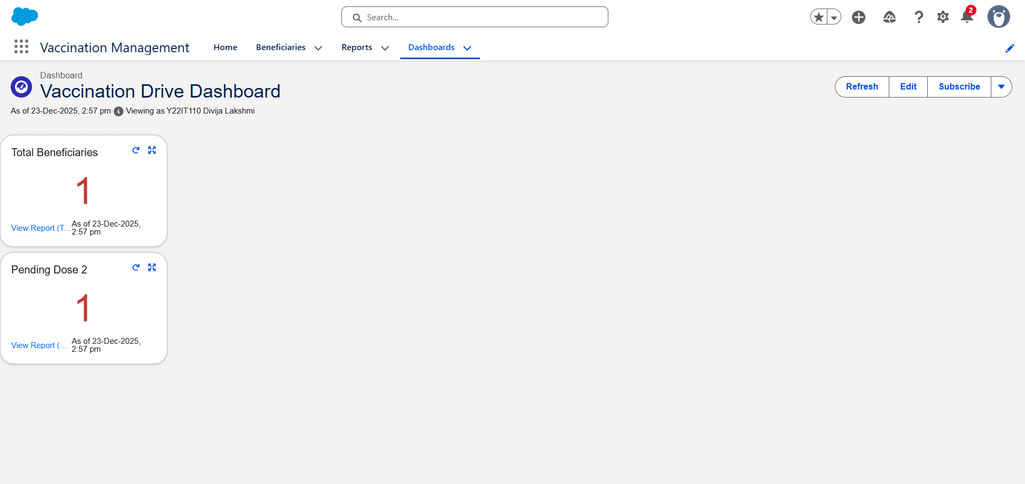
Figure 9: Vaccination Drive Dashboard with Metrics

Security
Profiles and permission sets were reviewed to control access.

Phase 10: Quality Assurance Testing

Testing Approach
Manual testing was performed using sample beneficiary records.

Sample Test Case
- Use Case: Create Beneficiary Record
- Input: Beneficiary details with Dose 1 = Completed, Dose 2 = Pending
- Expected Result: Record saved successfully
- Actual Result: Record saved and reflected in reports and dashboard

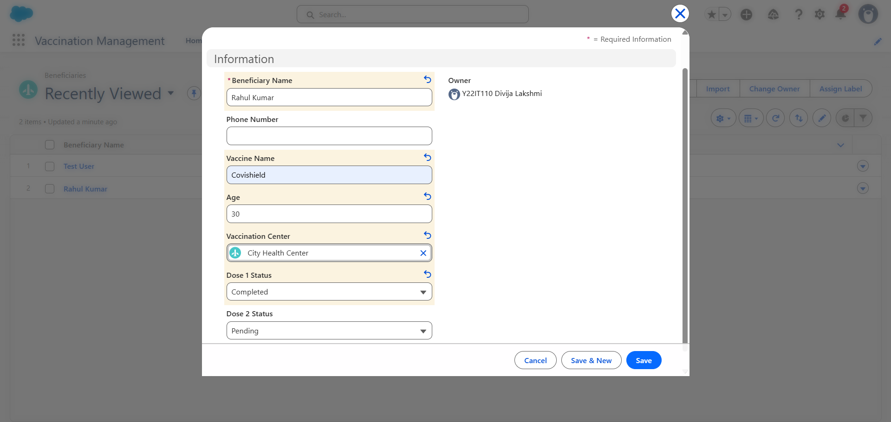
Figure 10: Creating a Beneficiary Record

Sample Test Case
- Use Case: Create Beneficiary Record
- Input: Beneficiary details with Dose 1 = Pending, Dose 2 = Completed
- Expected Result: System should prevent saving the record and display an error message stating that Dose 2 cannot be completed before Dose 1.
- Actual Result: System displays validation error message and does not allow the record to be saved until Dose 1 is marked as Completed.

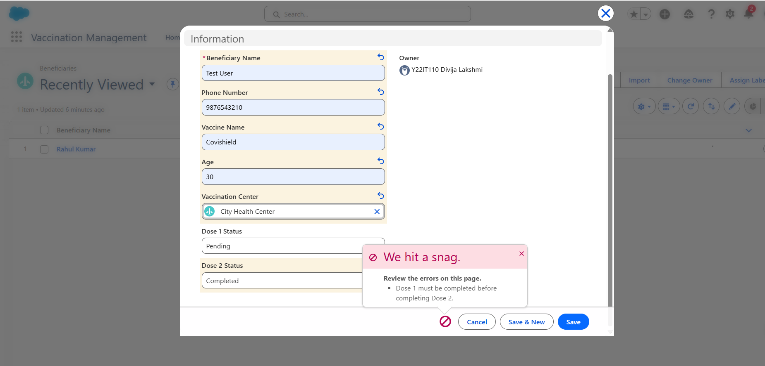
Figure 11: Validation Rule Triggered When Dose 2 is Marked Completed Before Dose 1

Conclusion
The Vaccination Management System successfully demonstrates the use of Salesforce CRM for managing vaccination data. The project covers core Salesforce concepts including custom objects, validation rules, reports, dashboards, and Lightning UI customization. It provides a strong foundation for real-world healthcare CRM implementations.

Future Enhancements
- Integration with external health systems using APIs
- SMS/Email notifications for dose reminders
- Role-based dashboards
- AI-driven insights using Salesforce Einstein

